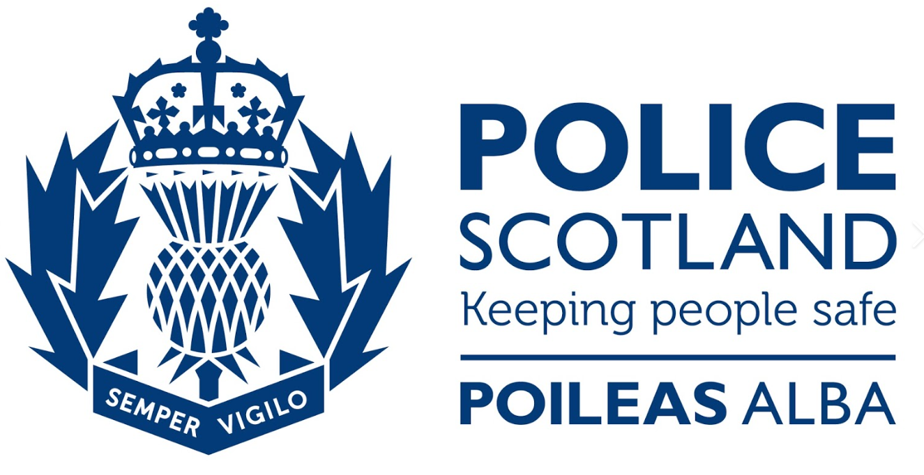

Banff and Buchan West Community Council Report

1 July – 31 August 2024

**In the event of a Police non-attendance at the meeting, can you ensure that you provide any concerns raised at the meeting to the Police ASAP by email to ensure we capture any issues early and can provide an update at the next meeting.**

This report covers progress we have made in dealing with your priorities for Banff and Buchan West during the period 1 July – 31 August 2024. Although no figures or comparison data will be provided a light touch overview will be provided.

The report aims to highlight emerging issues in your area, and to provide crime prevention advice and guidance to Community Council members and residents you represent. Our focus is to reduce crime and disorder, help create safer communities and respond effectively to local concerns.

Keeping people safe is at the heart of local Policing and our community based approach in Banff and Buchan West continues to reduce crime and increase detection rates across the area.

The local priorities are;
* Protecting Vulnerable People
* Serious and Organised Crime
* Anti-Social Behaviour, Violence and Disorder
* Road Safety and Road Crime
* Acquisitive Crime

Protecting Vulnerable People

Banff and Buchan West officers remain, in many instances, first responders to persons in crisis and provide an opportunity to really listen and get assistance to those in need. It is our aim to continue to work closely with key partner agencies to ensure the best and most suitable help is offered to persons in need.

We continue to see Officers in Banff and Buchan West attending a number of calls in respect of residents across Banff and Buchan West area who have had concerns expressed for them or reported missing by family members, associates or other agencies who have advised the person has failed to engage with their services.

Some of the incidents have involved Officers attending to provide initial medical care, facilitating triage by Scottish Ambulance Service and in the most severe cases, transferring the person to hospital for care in the absence of an Ambulance.

The local Policing Team hold a list of Support Services available to residents of Aberdeenshire in respect of Mental Health and Wellbeing and will signpost to other services where appropriate.

Antisocial behaviour, Violence and Disorder

This priority encompasses a wide range of offences from lower-level nuisance and disorder to more serious crimes of Assault and Robbery.

During the summer months, there were assaults reported within the area. Most of these incidents took place in residential and public places. These incidents are either detected or have lines of enquiry that are currently being progressed.

Police and partners continue to look to the Community for any suggestions in relation to diversionary activities which could be used for those on the periphery of criminality or to provide safe areas/activities for young persons to meet friends and hangout.

Our Early Intervention Officer, Amanda Richardson, is looking to engage the local community, businesses and partners to organise activities across Banff and Buchan West for young people to participate in. If you can offer time, funding or a safe space, or have any other ideas please contact Amanda via northeastearlyintervention@scotland.police.uk.

Any incidents of vandalism are to be reported via 101 and will be dealt with timeously.

Acquisitive Crime

Acquisitive crime encompasses a number of crimes such as Theft by Housebreaking, Vehicle Crime, Shoplifting, Fraud and Theft.

Members of the community are to ensure they remain vigilant with their vehicle and property security. Ensuring keys are stowed away out of sight from the front door and the vehicle is locked securely.

As indicated in previous reports, Fraud continues to have an upward trends with new scams being reported on a daily basis across the country.

Fraud types are as follows;

- Contact via WhatsApp pretending to be son/daughter requesting money for broken phone.
- Computer ‘Pop Ups’ advising computer is frozen or compromised and to call a specific number for repairs.
- Cryptocurrency Investment indicating they will pay off mortgages or double pension.
- Purchase of high value goods on Facebook Marketplace and eBay, deposit paid and item not existing/not delivered.
- Fake Currency in circulation.

If in doubt, compare the note to one that you know is genuine.

STOP – Taking a moment to stop and think before parting with your money or information
CHALLENGE – Could it be fake? It’s ok to reject/refuse or ignore any requests
PROTECT – Contact your bank immediately if you think you’ve fallen for a scam and report all scams to Action Fraud.

Police Scotland has a dedicated Crime Reduction Unit who are specialised in this matter and are able to provide support and assistance to businesses as well as private residences in order to maximise security measures.

A wealth of information and advice relating to home security as well as other Police related matters can be accessed on the Police Scotland website at: https://www.scotland.police.uk/advice-and-information/

Call 101 to report fraud or 999 in an emergency.

Where to Report Scams

Scams
In Scotland, report all scams to Advice Direct Scotland by calling 0808 164 6000 (Mon-Fri 9am-5pm) or online at www.consumeradvice.scot
Fraud
If you have been the victim of fraud, report it to Police Scotland on 101 or 999 in an emergency.
Suspicious Emails
You can forward suspicious emails to report@phishing.gov.uk and send links from websites which you think are trying to scam the public to the National Cyber Security Centre's scam website reporting service at www.ncsc.gov.uk/section/about-this-website/report-scam-website
Suspicious Text Messages
If you receive a suspicious text message you can forward it to 7726. The free-of-charge ‘7726’ service enables your provider to investigate and take action if malicious content is found.

Road Safety & Road Crime

Safety on our roads remains a priority within the Banff and Buchan West area. Officers have been engaging in roadside speed checks and offending drivers being dealt with in accordance with guidance relevant to the speeds detected. In addition to this, our colleagues in the Roads Policing department, as well as the safety camera unit are continuing in their efforts to educate and enforce on our roads.

We are continuing in our actions to tackle antisocial driving across the region with a number of drivers being dealt with in relation to motoring offences. We will continue to patrol hotspots and carry out follow up enquiries on any reports of antisocial driving received in an effort to gain sufficient evidence to charge those responsible for antisocial driving.

We continue to actively monitor routes across our area and conduct speed checks to educate and enforce road traffic legislation. The variable speed detection sign has been deployed across the region this month which has been a positive reminder to drivers of their speed.

During July and August, there were 41 occasions where Police have been contacted in relation Road Traffic collisions, which ranged from no injury to serious injury.

Police also received 42 reports with regards to Road Traffic Matters these can vary between intelligence regarding the manner of a person’s manner of driving, obstructions, break downs and assisting members of the public.

There were multiple reports regarding to untaxed or abandoned vehicles. Members of the public may feel that this is a Police matter to deal with however I would urge persons to contact DVLA with regards to this as they will have more authority over the vehicle in question.

In relation to road traffic operations, these are advertised on social media platforms.

During the summer months there was a Summer Drink/Drive campaign throughout Police Scotland.
This is Police Scotland’s contribution to Operation Spotlight, the NPCC’s UK-wide initiative tackling the July statistical peak in casualty collisions - including Killed & Seriously Injured collisions.

Serious & Organised Crime

Officers in Banff and Buchan West have been proactive in their approach in relation to Serious and organised crime with a number of persons being stopped by Officers and searched using Police powers to search for Possession of Controlled Drugs and Offensive Weapons with a number of seizures of both.

Community Beat Officer as well as other officers find that partnership working is the key to success.
Operation Protector is led by Police but values the expertise of partnership agencies such as housing, social work and safer communities etc. We have seen many positive changes with this operation and again it is something we will continue to do.

We would as residents to remain vigilant to issues and report any suspicious vehicles or behaviour to Police Scotland so we can ‘Ditch the Dealer’ and put a stop to the untold misery drugs cause to individuals, families and communities as a whole. The below form can be used to see what information is helpful to your Community Policing Team.

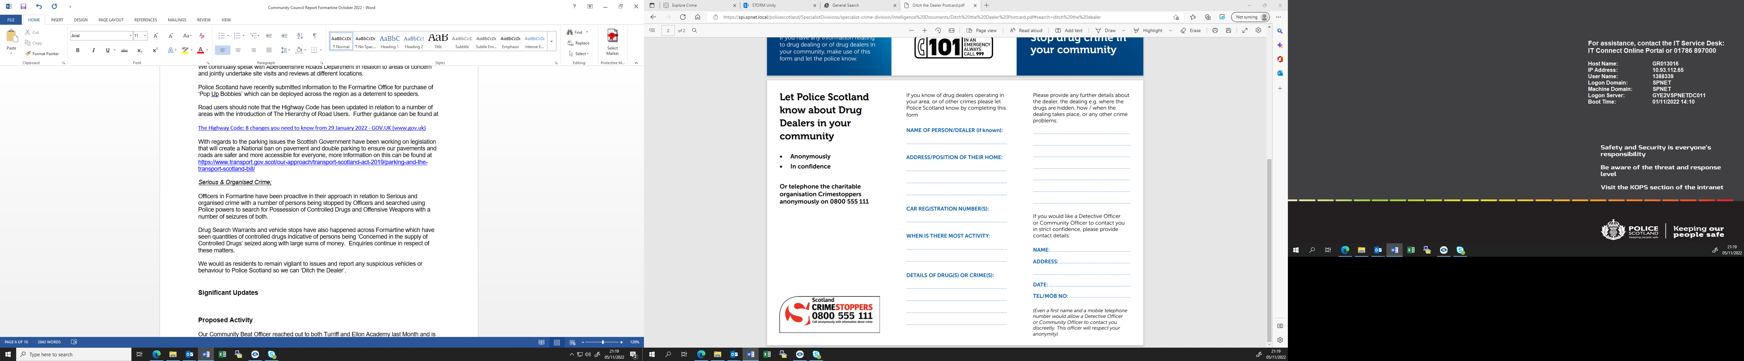

Crime Prevention

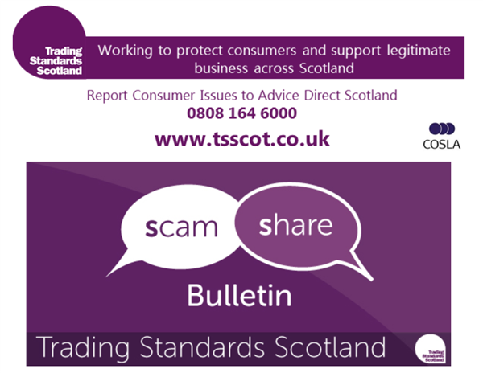
Stay Scam Aware
Scams
In Scotland, report all scams to Advice Direct Scotland by calling 0808 164 6000 (Mon-Fri 9am-5pm) or online at www.consumeradvice.scot
Fraud
If you have been the victim of fraud, report it to Police Scotland on 101 or 999 in an emergency.
Suspicious Emails
You can forward suspicious emails to report@phishing.gov.uk and send links from websites which you think are trying to scam the public to the National Cyber Security Centre's scam website reporting service at www.ncsc.gov.uk/section/about-this-website/report-scam-website
Suspicious Text Messages
If you receive a suspicious text message you can forward it to 7726. The free-of-charge ‘7726’ service enables your provider to investigate and take action if malicious content is found.
Crimes In Your Area

Banff
No incidents of note to report
Macduff
No incidents of note to report.
Porstsoy
No incidents of note to report.
Aberchirder
No incidents of note to report.
King Edward/Crudie
No incidents of note to report.
Gamrie
No incidents of note to report.
Cornhill
No incidents of note to report.
Fordyce and Sandend
No incidents of note to report.
Whitehills
No incidents of note to report.
Alvah/Forglen
No incidents of note to report.

Mental Health and Suicide Awareness Contacts

Mind Infoline • 0300 123 3393 • info@mind.org.uk
Information on types of mental health problem, where to get help in your area, medication and alternative treatments, advocacy.

Mind Legal Line • 0300 466 6463 • legal@mind.org.uk
Legal advice on mental health, mental capacity, and community care human rights and discrimination/equality.

Victim Support • 0845 30 30 900 • www.victimsupport.org.uk
Free and confidential help to victims of crime, witnesses, and anyone else affected across England and Wales.

Samaritans • 08457 90 90 90 • www.samaritans.org
Support and advice for people experiencing a crisis.

Alzheimer’s Society • 020 7423 3500 • www.alzheimers.org.uk
Advice and information on supporting people affected by dementia in England, Wales and Northern Ireland.

Neighbourhood Return • www.ourturn.org.uk
Helps find lost people with memory problems quickly, and gets them home safely.

Self Help Services • www.selfhelpservices.org.uk
A user-led mental health charity providing primary care mental health services and self-help initiatives to people across the North.

NHS Choices • www.nhs.uk
Information on local services, including mental health services and emergency departments.

NHS24 Mental Health Hub • 111 • www.nhsdirect.nhs.uk
Information and advice on a wide range of health issues via telephone, email and the internet.

Local council websites • www.aberdeenshire.gov.uk
Will provide a directory of council services in your area.

Prevent Suicide NE App (available for free download on Android and iOS, info also available at https://www.preventsuicideapp.com/ ) – contains info on how to ask someone about their thoughts of suicide, a directory of local and national supports and an option to create a safe plan

Guidance booklets with further information are available through SAMH’s website (https://www.samh.org.uk/about-mental-health/samh-publications/suicide-publications)

