ALVAH AND FORGLEN COMMUNITY COUNCIL
ANNUAL GENERAL MEETING
ALVAH HALL: TUESDAY 24 JUNE 2025
MINUTES
Website:www.alvahforglencc.wordpress.com
Facebook: https://www.facebook.com/AlvahForglenCC/

1. Present
Doug Hill (Chairman), Carol Cox (Vice Chairman), Mike Dewhurst (Treasurer), Barbara Foad (Secretary), Caroline Jones and Peter Dow
In attendance: Cllr Stewart Adams and Andrew Webster (Friends of Forglen).
2. Apologies
Apologies were received from Cllr John Cox and Jacky Player.
3. Minutes of Previous Meeting.
The minutes of the previous AGM held on 25 June 2024 which had been agreed by email were formally approved.
4. Chairman’s Report
The Chairman reported that:
- The communal tubs have been planted this year with perennials.
- The Jubilee Plantation has been well maintained over the year and continues to grow.
- After a period of trials and testing, hybrid meetings to allow remote access to meeting are now used as standard.
- The Arts Group has arranged shows at Alvah and Forglen Halls, bringing the community together and assisting in the continued use of both halls.
- The community council sends its best wishes and thanks to Carol Rewston for all her work since the CC reformed in 2014 for doing flower planting and maintenance in Alvah and Forglen.
5. Secretary’s Report
The Secretary reported that:
- At the AGM in June 2024, we had 11 members. After the election and Inaugural Meeting in September 2025 hosted by the Area Manager we had 8 members. There have been two resignations and one co-option in 2024 to 2025. We currently have 7 members.
- AFCC had not objected to any planning applications over the past year. AFCC did not object but stated reservation on the application for an 80-acre solar farm.
- AFCC did not pursue the process of consultation for a new Community Action Plan. As had been intended due to members being unable to commit to the time needed.
- We are greatly appreciative of the support we have had from the Area Manager’s office.
- A good rapport had been maintained with the Roads Department and Landscape Department who have always responded quickly to AFCC concerns and observations. The Roads Department, as usual had responded very effectively.
- AFCC was grateful for the continued regular attendance and advice of the local Aberdeenshire councillors.
- AFCC website and Facebook were always up to date and had proved a good way to connect with our local residents and beyond. We have installed cupboards with equipment to enable hybrid community council meetings in both halls and online access is usually successful. This has enabled wider participation from the community with our meetings.

6. Treasurer’s Report and Approved Accounts
The Treasurer reported that:
- The accounts (attached as Annex) were distributed to all councillors before the meeting
- AFCC is on a sound financial footing and the members are invited to think of suitable uses for the balance of £2,700.
- Income was from the Admin Grant from Aberdeenshire Council of £680 and two grants from the Deuchries Wind Farm Community Fund to enable hybrid meetings in the halls.
- Expenditure was on the IT equipment to enable meetings, membership of APRS, the GDPR fee and Insurance.
The accounts were approved. (See Appendix 1) Grateful thanks to Rebecca Ross of the Banffshire Partnership for auditing our accounts.
7 Confirmation of Officers
Cllr Stewart Adam presided over the election of officers and thanked the members of the community council for all they do.
Chairman- Doug Hill was proposed by Carol Cox and seconded by Caroline Jones
Vice-Chair- Carol Cox was proposed by Barbara Foad and seconded by Mike Dewhurst
Secretary – Barbara Foad was proposed by Doug Hill and seconded by Carol Cox
Treasurer- Mike Dewhurst was proposed by Barbara Foad and seconded by Caroline Jones
The Officers were elected unanimously

8. Dates of Future Meetings
The dates of future meetings were agreed (see Appendix 2).

Barbara Foad
Secretary
Alvah & Forglen Community Council

Appendix 1

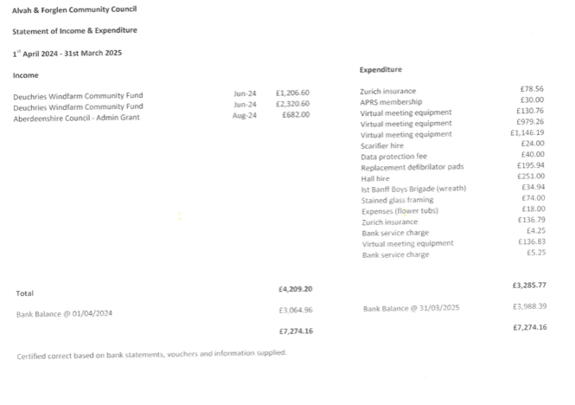
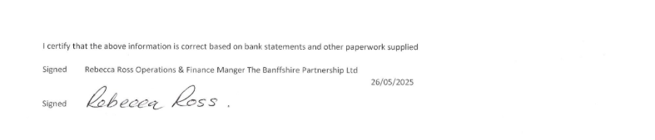
Appendix 2

ALVAH AND FORGLEN COMMUNITY COUNCIL
MEETING DATES
TUESDAYS 19:00 (including AGM on 30 JUNE 2026)

29 JULY 2025 | FORGLEN HALL
30 SEPTEMBER 2025 | ALVAH HALL
28 OCTOBER 2025 | FORGLEN HALL
25 NOVEMBER 2025 | ALVAH HALL
16 DECEMBER 2025 | FORGLEN HALL
27 JANUARY 2026 | ALVAH HALL
24 FEBRUARY 2026 | FORGLEN HALL
31 MARCH 2026 | ALVAH HALL
28 APRIL 2026 | FORGLEN HALL
26 MAY 2026 | ALVAH HALL
30 JUNE 2026 | FORGLEN HALL

